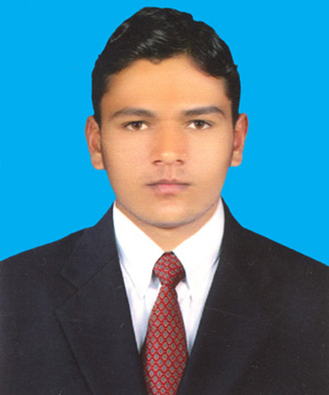

|  |  |  |  |  |  |  |  |  |  |  |  |  |  |  |  |  |  |  |  |  |  |  |  |  |  |  |  |  |  |  |  |  |  |  |  |  |  |  |  |  |  |  |  |  |  |  |  |  |  |  |  |  |  |  |  |  |  |  |  |  |  |  |  |  |  |  |  |  |  |  |  |  |  |  |  |  |  |  |  |  |  |  |  |  |  |  |  |  |  |  |  |  |  |  |  |  |  |  |  |  |  |  |  |  |  |  |  |  |  |  |  |  |  |  |  |  |  |  |  |  |  |  |  |  |  |  |  |  |  |
| --- | --- | --- | --- | --- | --- | --- | --- | --- | --- | --- | --- | --- | --- | --- | --- | --- | --- | --- | --- | --- | --- | --- | --- | --- | --- | --- | --- | --- | --- | --- | --- | --- | --- | --- | --- | --- | --- | --- | --- | --- | --- | --- | --- | --- | --- | --- | --- | --- | --- | --- | --- | --- | --- | --- | --- | --- | --- | --- | --- | --- | --- | --- | --- | --- | --- | --- | --- | --- | --- | --- | --- | --- | --- | --- | --- | --- | --- | --- | --- | --- | --- | --- | --- | --- | --- | --- | --- | --- | --- | --- | --- | --- | --- | --- | --- | --- | --- | --- | --- | --- | --- | --- | --- | --- | --- | --- | --- | --- | --- | --- | --- | --- | --- | --- | --- | --- | --- | --- | --- | --- | --- | --- | --- | --- | --- | --- | --- | --- | --- |
| **CONTACTS**  **wqasimg@gmail.com**   |  |  | | --- | --- | | Cell | **+923244929494** | |  |  | |  |  | |  | **Johartown, Lahore** | |  |  |  |  | | --- | |  | |  |   **Skills**  JavaScript  Core Php  Css  JQuery  Adobe Photoshop  Bootstrap  Html  Database Management System  MySql  React.js    **Languages**   |  |  |  |  | | --- | --- | --- | --- | |  | English |  |  | |  | Urdu |  |  | |  |  |  |  |      |  | | --- | |  | |  | | |  |  |  | | --- | --- | --- | |  | **Waseem Qasim** |  | |  | *web dEVELOPER* |  | |  | * Committed team player with strong analytical and problem * Solving skills. * Willingness to relocate and ability to quickly adapt to new environments and technologies. * Dedicated to successful project completion. |  |  |  |  |  |  |  |  | | --- | --- | --- | --- | --- | --- | | **Experience** | | | | |  | |  | ***Php&React.js web Developer*** | | *Feb/2020 –Sep/2021* | |  | *NextLogixs (IT-Solutions)* – Lahore | | | |  | | |  | **Major Responsibilities:** | | | |  | * Supporting development, maintaining, and updating web portals as well websites. * Assisting in deployment and development of websites. * Writing codes for web based Solutions. * Technical documentation and presentation. * Troubleshooting websites problems.   **2. Major Accomplishment**  ♣ [www.bookertee.com](http://www.bookertee.com) (React.js)  ♣ [www.noklestv.com](http://www.noklestv.com) (React.js)  ♣ [www.afritickets.com](http://www.afritickets.com) (React.js) | | |  |  |  |  |  |  |  |  | | --- | --- | --- | --- | --- | --- | --- | |  | ***web Developer*** | | | *Dec/2019 –Feb/2020* | |  | |  | *Musawwar (IT-Solutions)* – Lahore | | | | |  | |  | | |  | **Major accomplishments:** | | | | |  | |  | **1. www.musawwar.com**  ♣ Develop The Full Website (www.mussawar.com)  ♣ Implement All Designing, Team Section, ContactUs Form,  **2. Employ Management System**  ♣ Develop &Implement Full Portal using(Php,bootstrap,js) | | | | |  | |  | ***web Developer*** | | | *2018 – 2019* | |  | |  | *Micrologicx (IT-Solutions)* – Faisalabad | | | | |  | |  |  | | |  | **Major accomplishments:** | | | | |  | | **1. Blood Bank Management System** | | | | | |  | ♣ Develop Complete Structure Admin And User Level. | | | | |  |   **Education**   |  |  | | --- | --- | |  |  |   MSc (CS) University of Agriculture fsd *2017-2019*  **INTERESTS**   |  | | --- | | Technologies  Sports  Book Reading  Music | |